**6 PULSE CODE MODULATION AND DEMODULATION**

**6.1 Objective**

To analyze PCM system and interpret the modulated and demodulated waveforms for various sampling frequency and to find the Signal to Quantization Noise Ratio of PCM system.

**6.2 Hardware Required**

PCM modulator trainer kit-AET-68M

PCM Demodulator trainer kit-AET-68D

Storage oscilloscope

Digital multimeter

**6.3 Wiring Diagram**

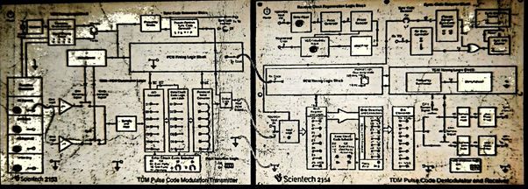

**Figure 6.1 Wiring Diagram for PCM Modulation and Demodulation**

**6.4 Introduction**

In Pulse code modulation (PCM) only certain discrete values are allowed for the modulating signals. The modulating signal is sampled, as in other forms of pulse modulation. But any sample falling within a specified range of values is assigned a discrete value. Each value is assigned a pattern of pulses and the signal transmitted by means of this code. The electronic circuit that produces the coded pulse train from the modulating waveform is termed a coder or encoder. A suitable decoder must be used at the receiver in order to extract the original information from the transmitted pulse train.

**6.5 Block Diagram** 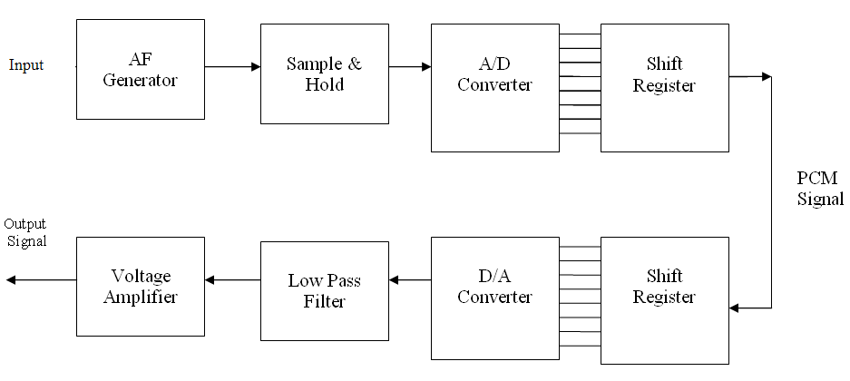

**Figure 6.2 PCM Modulator AND Demodulator**

**6.6 Pre Lab Questions**

1. What is meant by quantization?
2. Compare uniform and non-uniform quantization.
3. What are the steps involved in D/A converter?
4. Define aliasing.

**6.7 Procedure**

**6.7.1 PCM Operation** **(with AC input)**

1. Connect the modulator trainer to the mains and switch on the power supply.
2. Observe the output of the Sine generator using CRO, it should be a sine wave of 2KHz frequency with tuned amplitude.
3. Observe the Sample and Hold output using CRO.
4. Observe the output of the TDM PCM output using CRO.

**6.7.2 PCM Operation** **(with DC input)**

**Modulation**

1. Set DC source to some value say 4.4V with the help of the Knob and connect it to the A/D converter input and observe the output LED’s
2. Note down the digital code i.e. output of the A/D converter and compare with the theoretical value.

Theoretical value can be obtained by:

Where

1 LSB Value = Vref­/2n

Since Vref = 5 V and n=8

1 LSB Value = 0.01953

Example:

A/D Input voltage = 4.4 V

= 225.28(10)1

= 1110 0001(2)

So digital output is 1110 0001

1. Observe the Sample and Hold output using CRO.
2. Observe the output of the TDM PCM output using CRO.

Repeat the above steps for other Sampling frequencies.

Note: From this waveform you can observe the LSB bit enters the output first.

**6.7.3 Demodulation**

1. Connect TDM PCM signal of the modulator to the demodulators with the help of patch chord.
2. Connect transmitter clock to the receiver clock.
3. Observe the Sample and Hold output using CRO.
4. Observe the output of the LPF output using CRO.

**Sample work sheet**

* 1. Modulating signal : 4.4 V
  2. A/D Output (theoretical) : 1110 0001(2)
  3. A/D Output (practical) : 1110 0001(2)
  4. S-P Output : 1110 0001(2)
  5. D/A Converter output : 4.4 V

(Demodulated output)

**6.8 Model Graph**

**i) With AC Input**

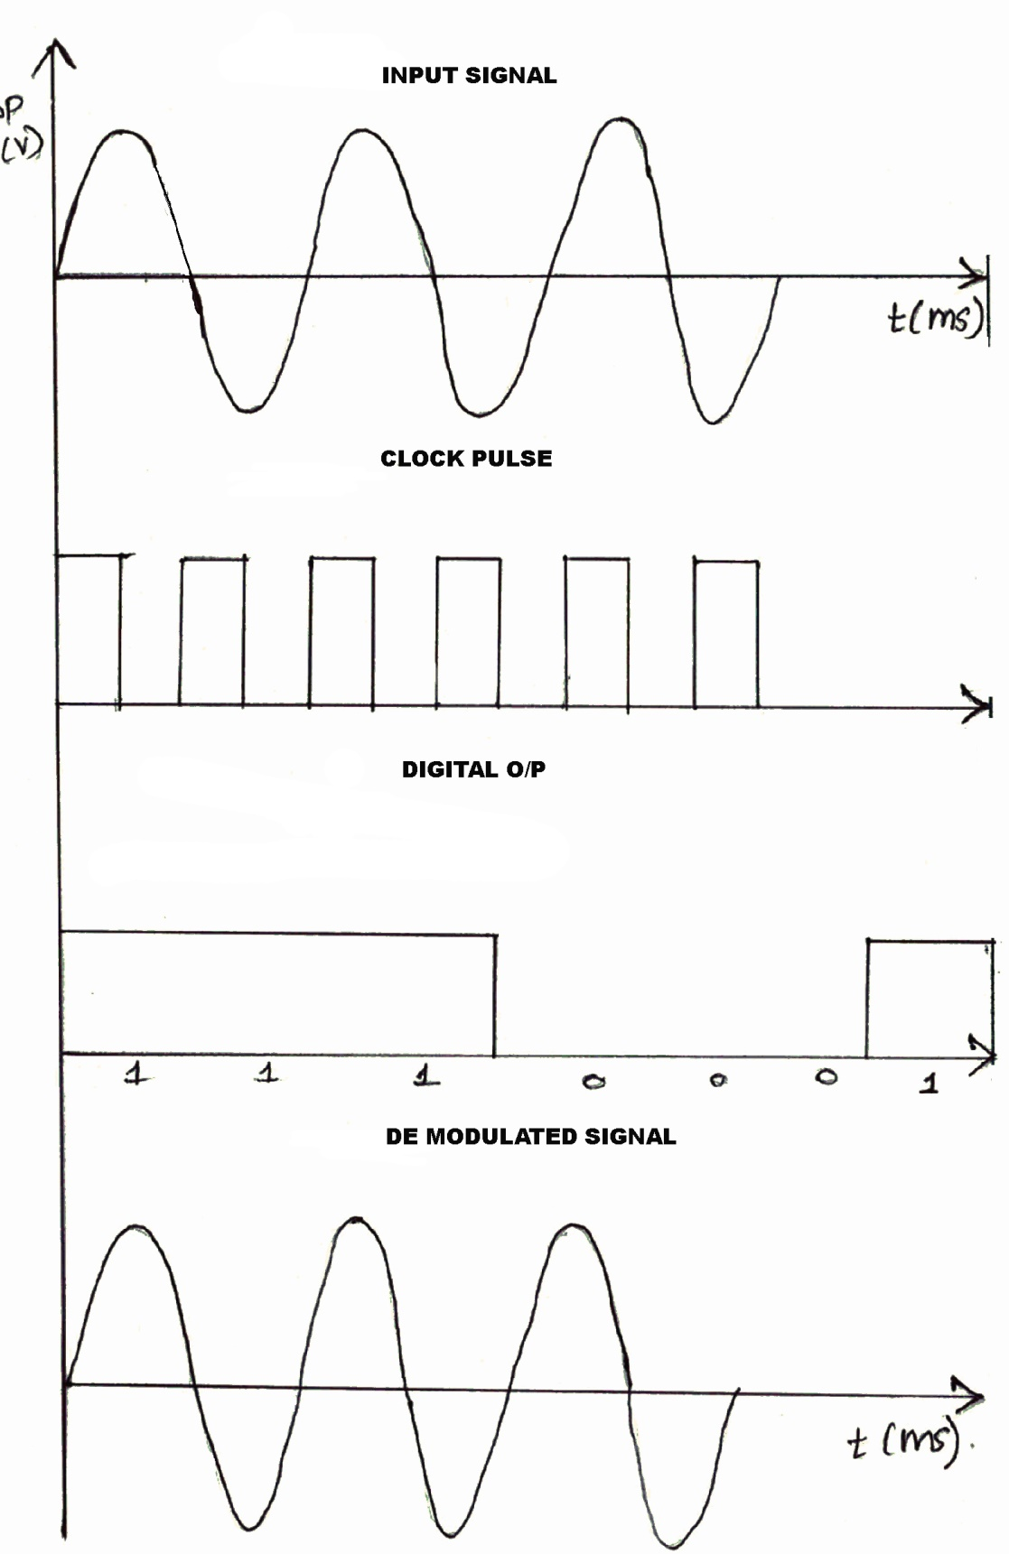

**Figure 6.3 PCM Waveform with AC input**

**ii)With DC Input**

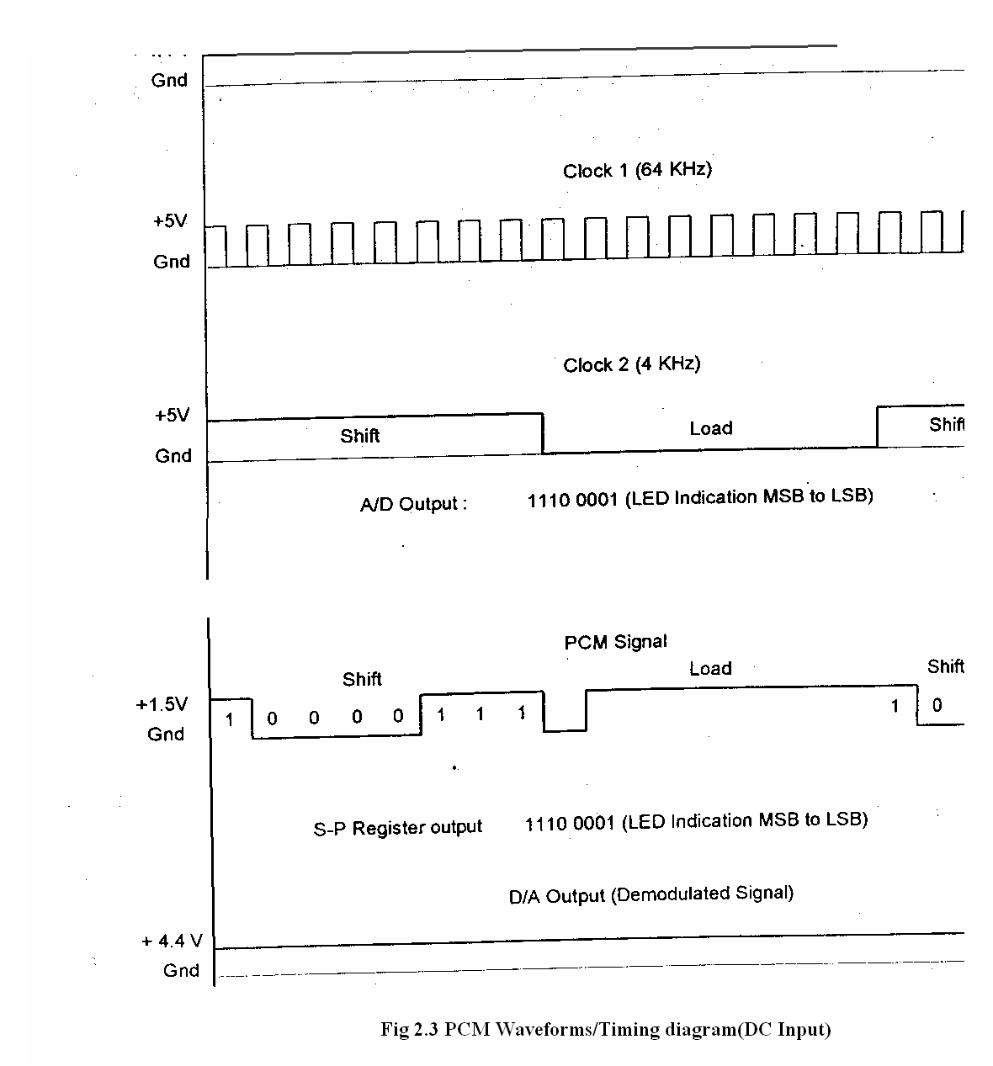

**Figure 6.4 PCM Waveform with DC input**

**6.9 Observation**

**PCM Modulation (With AC input)**

|  |  |  |
| --- | --- | --- |
| **Signal** | **Amplitude** | **Time Period** |
| AC input |  |  |
| Clock Signal |  |  |
| Sample and hold signal |  |  |
| PCM Output |  |  |

**PCM Demodulation (with AC input)**

|  |  |  |
| --- | --- | --- |
| **Signal** | **Amplitude** | **Time Period** |
| D/A Converter output Signal |  |  |
| LPF output signal |  |  |
| Demodulated output |  |  |

**PCM Modulation (With DC input)**

|  |  |  |
| --- | --- | --- |
| **Signal** | **Amplitude** | **Time Period** |
| DC input |  |  |
| Clock Signal |  |  |
| PCM Output |  |  |

**PCM Demodulation (With DC input)**

|  |  |  |
| --- | --- | --- |
| **Signal** | **Amplitude** | **Time Period** |
| D/A Converter output Signal |  |  |
| LPF output signal |  |  |
| Demodulated Output |  |  |

* 1. **Post Lab Questions**

1**.** What is quantization error?

2. What are the major sources of noise in a PCM system?

3. What is meant by encoding?

**6.11 Lab Result**

Thus the Pulse Code modulation and demodulation were performed and graphs were plotted.

**7 DIFFERENTIAL PULSE CODE MODULATION AND DEMODULATION**

**7.1 Objective**

To analyze DPCM system and to interpret the modulated and demodulated waveforms for various sampling frequency.

**7.2 Hardware Required**

Adcl-07 Kit

20 MHz Dual Trace Oscilloscope

Connecting Chords

Power Supply

Note: Keep the Switch faults in Off Position

**7.3 Introduction**

Differential PCM is quite similar to ordinary PCM. Each word in this system indicates the difference in amplitude, positive or negative, between this sample and the previous sample. Thus the relative value of each sample is indicated rather than, the absolute value in normal PCM.

**Block Diagram for DPCM**

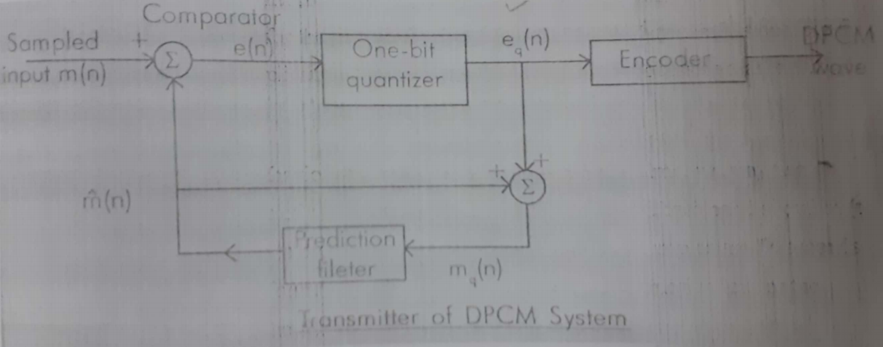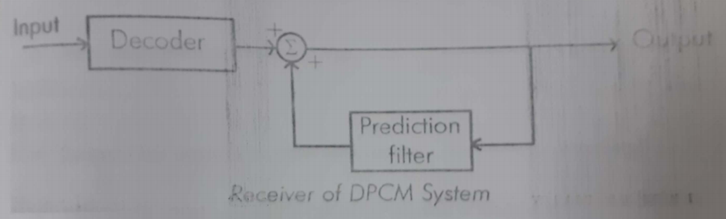

**Figure 7.1 Block diagram of DPCM System**

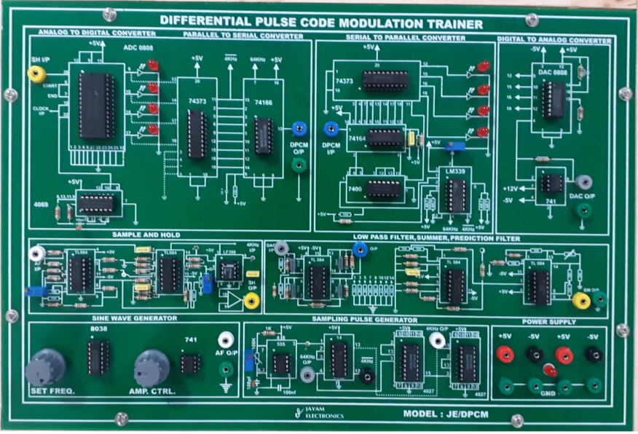

**Figure 7.2 DPCM trainer kit**

Output

**7.4 Prelab Questions**

1. What is DPCM?
2. What is the significance of prediction filter in DPCM?
3. Mention the merits of DPCM.

**7.5 Procedure**

**7.5.1 DPCM modulation**

1. Refer to the block diagram and carry out the following Connections and switch settings.
2. Connect power supply in proper polarity to the kit ADCL-07 and switch it ON.
3. Keep the clock frequency at 512 KHz by changing the jumper position of JP1

in the clock generator section

1. Keep the amplitude of the onboard sine wave, of frequency 500Hz to 1Vpp DPCM modulation.
2. Connect the 500Hz sine wave to the lN post of Analog Buffer.
3. Connect OUT post of Analog Buffer to lN post of DPCM modulator section.
4. Observe the sample output at the given test point the input signal is sampled at the clock frequency of 16 KHz.
5. Observe the linear predictor output at the PREDICTED OUT post of the Linear predictor in the DPCM modulator section.
6. Observe the differential pulse code modulate data ( DPCM) at the DPCM OUT post of the DPCM modulator section.
7. Observe the DPCM data at DPCM OUT post by varying input signal from to 2V.

**7.5.2 DPCM demodulation**

1. Connect the DPCM modulated data from the DPCM OUT post of the DPCM   
    Modulator to the lN post of the DPCM demodulator.
2. Observe the demodulated data at the output of summation block.
3. Observe the integrated demodulated data at the DEMOD OUT post of the DPCM   
    demodulator.
4. Connect the demodulated data from the DEMOD OUT post of the DPCM   
    demodulator to the lN post of the low-pass filter.
5. Observe the reconstructed signal at the OUT post of the filter. Use RST switch for   
    clear observation of output.
6. Now, simultaneously reduce the clock frequencies from 512 KHz to 256 KHz,128

KHz and 64 KHz by changing the jumper position of JP1 and observe the difference

in the DPCM modulated and demodulated data. As the frequency of clock decreases

DPCM Demodulated data at DEMOD OUT becomes distorted.

1. Observe various waveform as mentioned below

**7.6 Model Graph**



**Figure 7.3 DPCM Operation (With Ac Input) Modulation & Demodulation**

**Observation**

ON KIT ADCL-07

**Observe the following waveforms on the oscilloscope and plot on the paper.**

1. 500 Hz , l V pp input sine wave.
2. Sampled out at the provided test point SAMPLER OUT
3. Linear predictor out at PREDICTED OUT post.
4. DPCM data at DPCM OUT post
5. Line interface out at the given output test point of line interface block in DPCM Demodulator
6. Demodulated DPCM data at the output test point of summation block in DPCM demodulator.
7. Integrated demodulated data at the DEMOD OUT post of the DPCM demodulator
8. Reconstructed sine wave at the OUT post of the filter
9. Observe the data at different clock rates.

**DPCM Operation - with AC input**

|  |  |  |
| --- | --- | --- |
| **Modulation** | | |
|  | **Amplitude** | **Time Period** |
| AC Input |  |  |
| Clock – 1 Output |  |  |
| Sample and Hold Output |  |  |
| DPCM Output |  |  |

|  |  |  |
| --- | --- | --- |
| **Demodulation** | | |
|  | **Amplitude** | **Time Period** |
| DPCM Input |  |  |
| D/A Converter Output |  |  |
| LPF Output |  |  |
| Demodulated output  Prediction Filter Output |  |  |

**7.7 Post Lab Questions**

1. Define prediction error.
2. Differentiate PCM and DPCM.
3. What is prediction gain? State its significance.

**7.8 Lab Result**

Thus the Differential Pulse code modulation and demodulation were performed using the trainer kit.